How to Add Your Logo to the Poster
You can personalize this poster with your organization’s logo using any of the options below. Choose the one that works best for your team — no advanced design experience required!

Option 1: Use Adobe Acrobat Reader (No Design Software Needed)
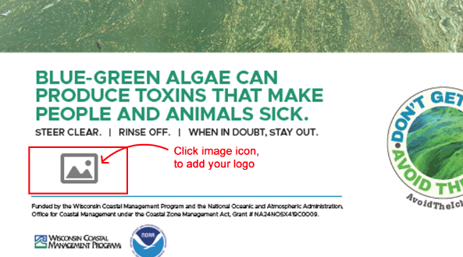
Would you like to upload one, two, or even three logos? This method is simplest, quick, and easy if you have Adobe Acrobat Reader (free version is fine). You'll just upload your logo into a pre-set spot on the poster. Note: If you have more than three logos, please use Option 2 or Option 3 below.
Steps:
- Download the PDF Poster from our website. It includes a built-in spot for your logo.
  - Please note that there are two versions, one for print (crop marks) and one for digital use. Download the document that you would like to use.
- Open the file using Adobe Acrobat Reader
  - Don’t have Adobe Acrobat, download for free here: get.adobe.com/reader
  - Note: If you're using a different PDF viewer, the logo upload feature might not work properly. Acrobat Reader is recommended.
- Scroll to the bottom of the poster and look for an image icon.
- Click the image icon this opens your file browser.
- Upload your logo (we recommend a PNG or JPG file).
- Y our logo will appear in the designated space on the poster.
- Save the updated PDF. You’re now ready to print or share it!

Option 2: Use Canva (Free Online Design Tool)
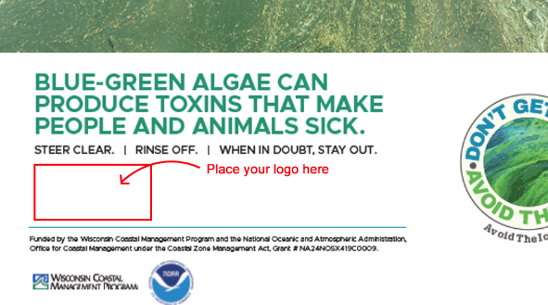
Use this if you prefer a web-based tool to visually place your logo.
Steps:
- Download the PDF Poster from our website. This version has a blank area for your logo.
  - Please note that there are two versions, one for print (crop marks) and one for digital use. Download the document that you would like to use.
- Go to www.canva.com and log in or create a free account.
- Click “Create a design” Choose “Custom size” and enter:
  - Width: 11 inches
  - Height: 17 inches
- In the left menu, click “Uploads” then “Upload files”, then select the PDF poster you downloaded.
- Once uploaded, drag the PDF into the blank canvas.
- Upload your logo (PNG or JPG works best) Drag it onto the poster.
- Resize and position your logo in the blank area under the text:
“Steer clear. Rinse off. When in doubt, stay out.”
- When you're done, click “Share” “Download” choose PDF or PNG, then click “Download.”

Option 3: Use Adobe Creative Suite (Photoshop)
If your team has design experience and access to Adobe Creative Suite, you can open the poster file in your preferred program and place your logo. Photoshop is recommended, but InDesign is a good alternative as well.
Using Adobe Photoshop - Steps:
- Download the PDF Poster from our website. This version has a blank area for your logo.
  - Please note that there are two versions, one for print (crop marks) and one for digital use. Download the document that you would like to use.
- Open Photoshop.
- Go to File Open, and select the PDF poster.
- The poster will open as a flat image.
- Go to File Place Embedded... and select your organization’s logo
  - A PNG file is ideal, but JPG file also works.
- Resize and position the logo as needed using the transform controls.
- Save your file:
  - File Save As PDF for high-quality sharing or printing.
  - Or export as PNG/JPG if needed for digital use.

